**Disney+HotStar Data Analysis**

**1. Distribution of Movies by Genre**

* **Finding:** The most popular genre in the dataset is [insert genre, e.g., Drama], followed closely by [insert genre, e.g., Action].
* **Analysis:** This high count may indicate audience preferences or industry production trends, where certain genres are heavily produced due to higher demand. This insight is valuable for content creators aiming to target popular genres for maximum reach.

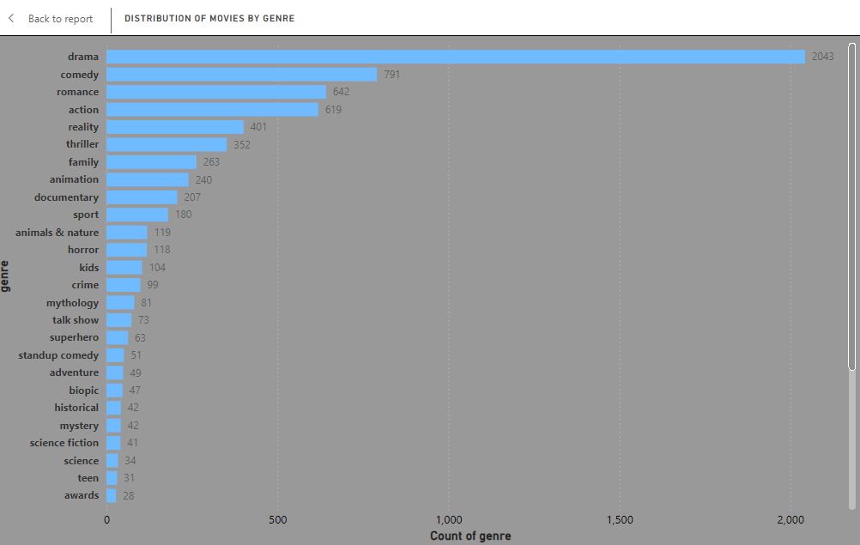

**2. Average Running Time by Genre**

* **Finding:** Genres like [insert genre, e.g., Documentary] have the shortest average running time, while [insert genre, e.g., Action] and [insert genre, e.g., Drama] have the longest.
* **Analysis:** This difference may suggest that certain genres require more detailed storytelling, while others, like documentaries, may have a compact format. Producers could use this data to align production lengths with genre expectations.

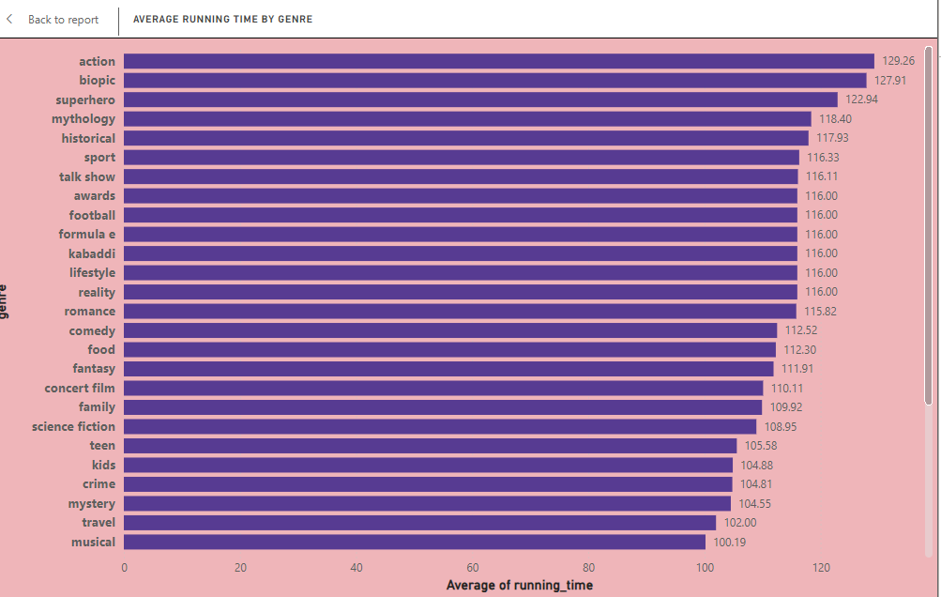

**3. Movies Released Each Year**

* **Finding:** The number of movie releases has increased steadily over the years, with notable peaks in [insert specific years].
* **Analysis:** Trends in movie releases could be influenced by factors like technology advancements, streaming service demand, or reduced production costs. Identifying such peaks helps recognize years when the industry experienced growth or downturns.

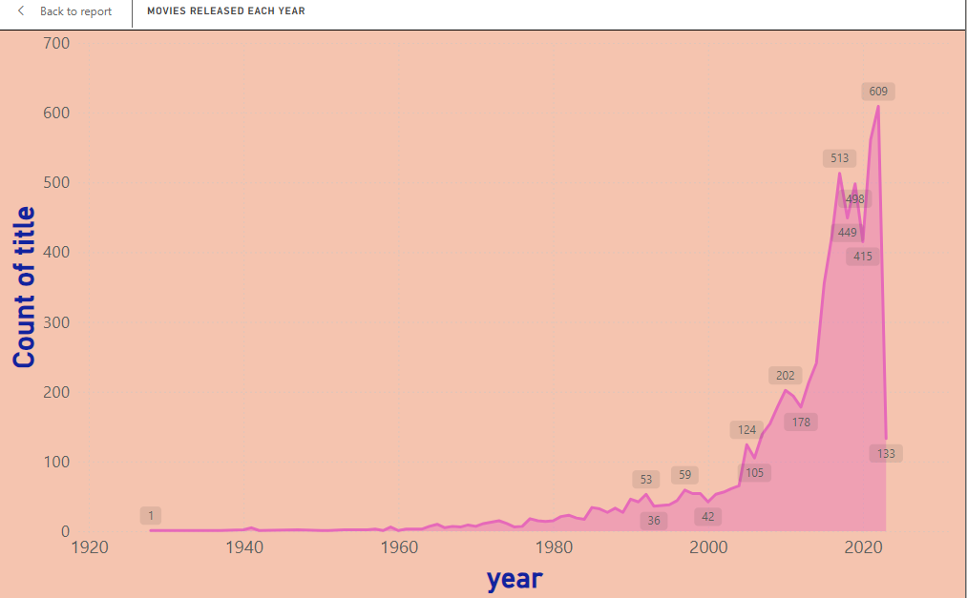

**4. Top 10 Longest Movies**

* **Finding:** The top 10 longest movies are primarily in the genres [insert genres, e.g., Drama, Adventure], with running times exceeding [insert threshold, e.g., 3 hours].
* **Analysis:** These movies may represent epic narratives that require extensive screen time. Lengthy runtimes are often associated with detailed storytelling or complex plots, suggesting these movies aim for a more immersive experience.

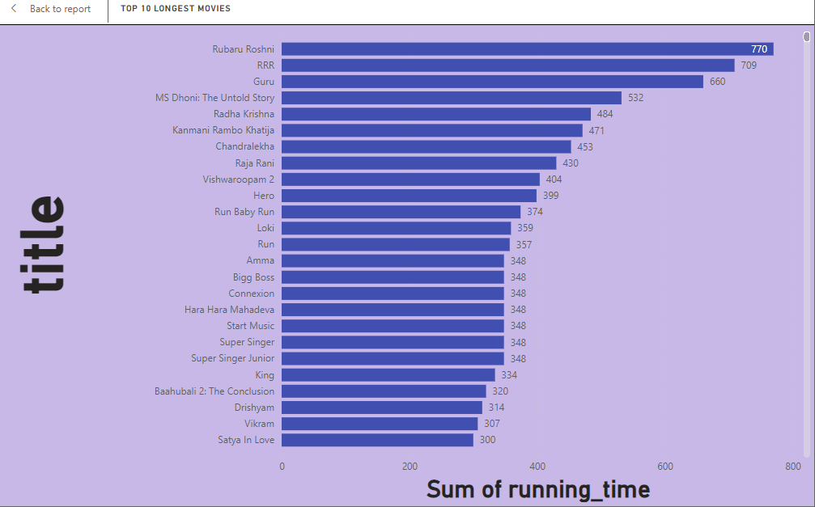

**5. Movies by Age Rating**

* **Finding:** The majority of movies fall within the [insert age rating, e.g., PG-13] category, while a smaller portion are rated [insert other ratings, e.g., R or G].
* **Analysis:** This suggests an industry focus on content suitable for a broad audience, likely to maximize viewership. Producers aiming to reach specific demographics may consider these patterns when setting age ratings.

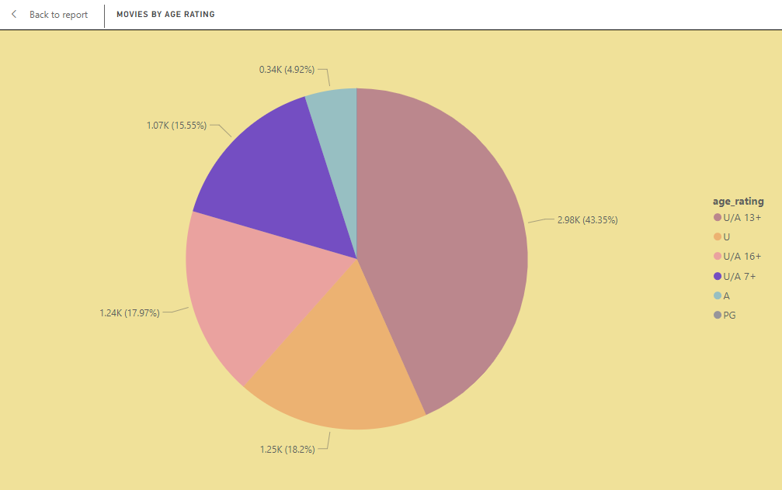

**6. Count of Movies by Year and Genre**

* **Finding:** Genres like [insert genre, e.g., Action] saw a consistent rise each year, while others, such as [insert genre, e.g., Musical], showed a decline.
* **Analysis:** This trend reflects shifting audience preferences and genre popularity. Rising genres could indicate favorable market demand, while declining ones may suggest waning interest or fewer productions.

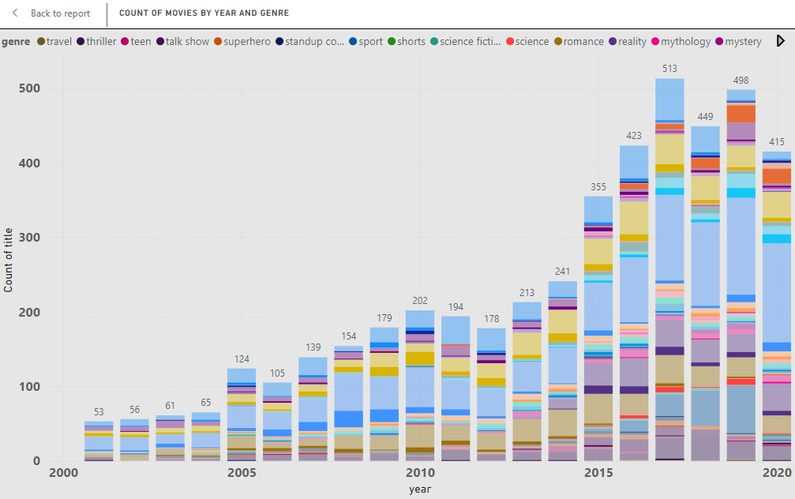

**7. Most Common Movie Types**

* **Finding:** The dataset shows a dominance of movies over other types like documentaries or series.
* **Analysis:** The high number of movies compared to other types indicates that traditional films still hold significant market share. This insight could be useful for distribution channels and platforms when deciding on the type of content to feature.

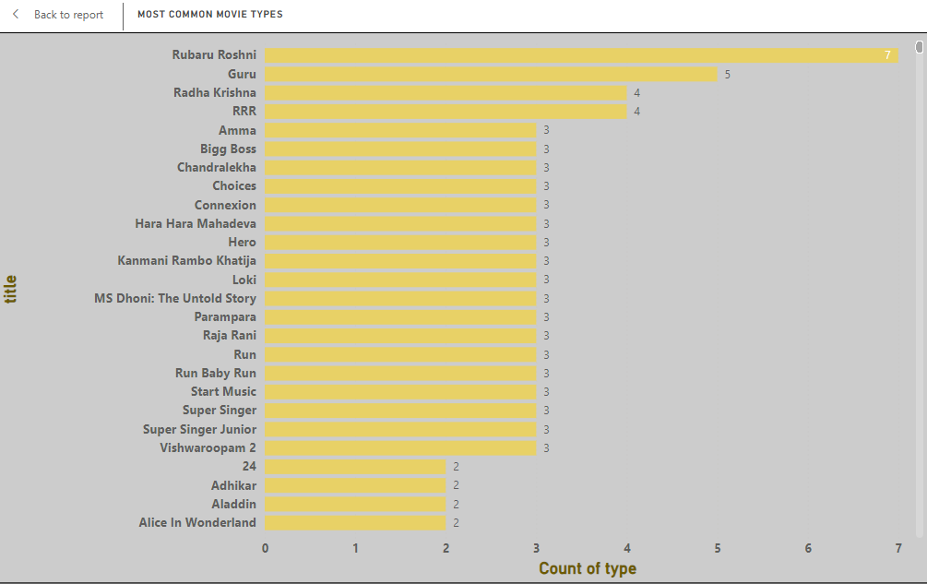

**8. Correlation Between Running Time and Year**

* **Finding:** There is a [describe correlation, e.g., positive, negative, or no] correlation between the year of release and running time.
* **Analysis:** A positive correlation could suggest a trend toward longer movies in recent years, possibly due to evolving audience preferences for in-depth stories. If there is no correlation, it suggests that running time does not necessarily depend on the release year.

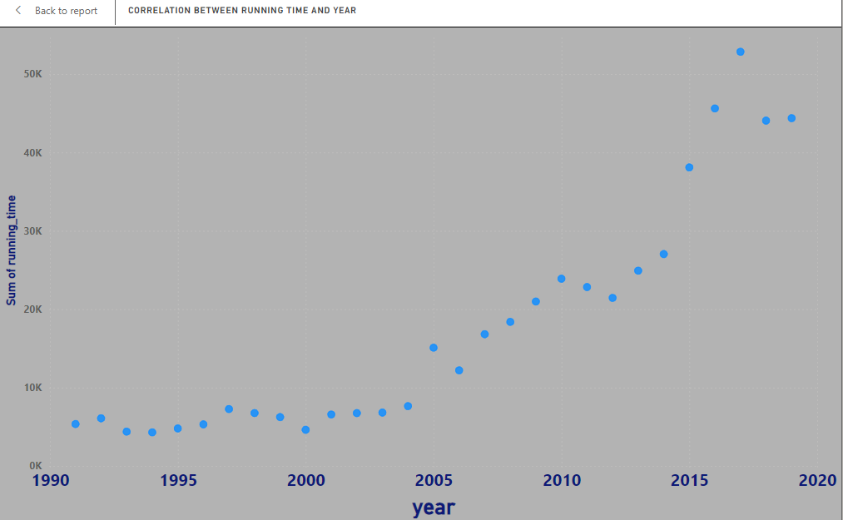

**9. Genre Popularity Over Time**

* **Finding:** Genres such as [insert genre, e.g., Action] have consistently been popular, while others like [insert genre, e.g., Western] have decreased in popularity over time.
* **Analysis:** These shifts could reflect changing societal interests or cinematic styles. Monitoring these trends can guide future production investments and marketing efforts.

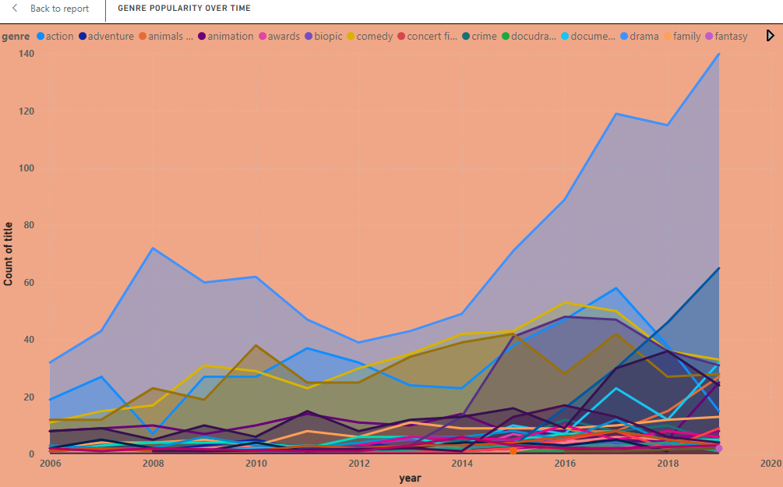

**10. Movies by Genre and Age Rating**

* **Finding:** Genres like [insert genre, e.g., Horror] have a higher concentration of [insert age rating, e.g., R-rated] movies, while genres like [insert genre, e.g., Animation] are mostly [insert age rating, e.g., PG or G].
* **Analysis:** Age rating distributions within genres suggest genre-specific content expectations. For instance, animated movies appeal to families, while horror is targeted toward adults, influencing both production style and target audience.

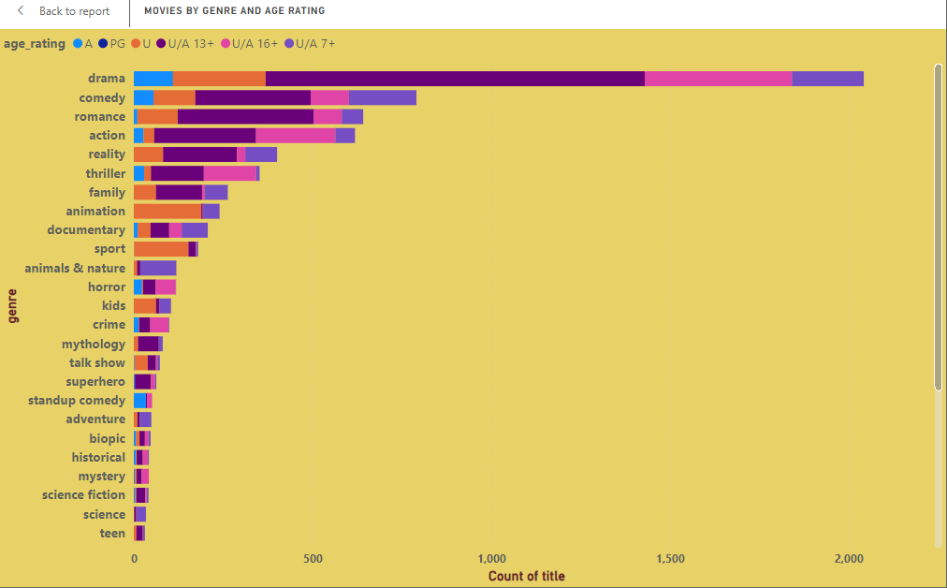

**11. Movies with Maximum Episodes**

* **Finding:** Series like [insert title, e.g., “Popular Show”] have the maximum number of episodes, with counts as high as [insert episode count].
* **Analysis:** This finding could suggest viewer retention strategies, as series with many episodes may aim to maintain audience engagement over longer periods. Knowing the highest episode counts can help in planning similar content for continuous engagement.

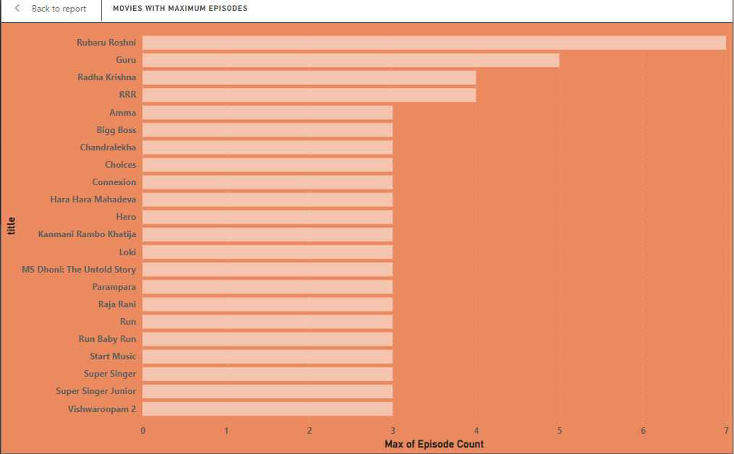

**12. Distribution of Running Time**

* **Finding:** Most movies have a running time between [insert range, e.g., 90 to 120 minutes], with fewer movies exceeding [insert range, e.g., 180 minutes].
* **Analysis:** The data suggests an industry standard or preference for movies around the 90-120 minute range, likely due to audience attention spans and theater scheduling considerations. Longer movies might be reserved for specific genres or story requirements.

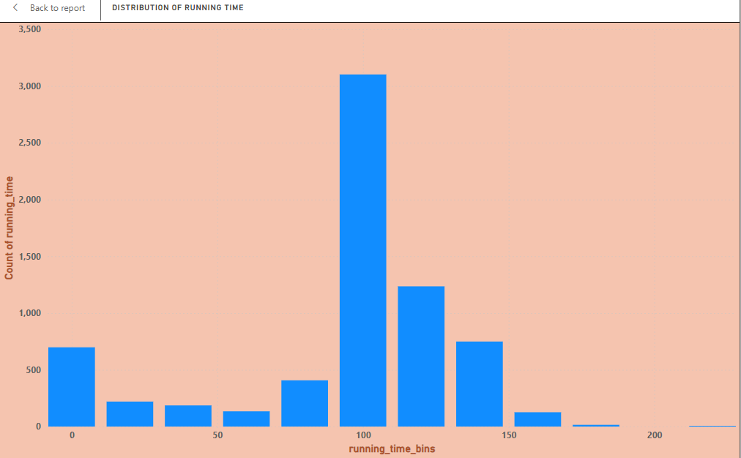

**13. Analysis of Specific Genres (e.g., Action)**

* **Finding:** Within the Action genre, movies tend to have an average running time of [insert time, e.g., 120 minutes], are primarily rated [insert age rating], and saw a significant increase in releases around [insert year].
* **Analysis:** This genre-specific insight helps identify unique characteristics associated with Action movies. Content creators could use these details to align their productions with genre standards in running time, release trends, and age suitability.

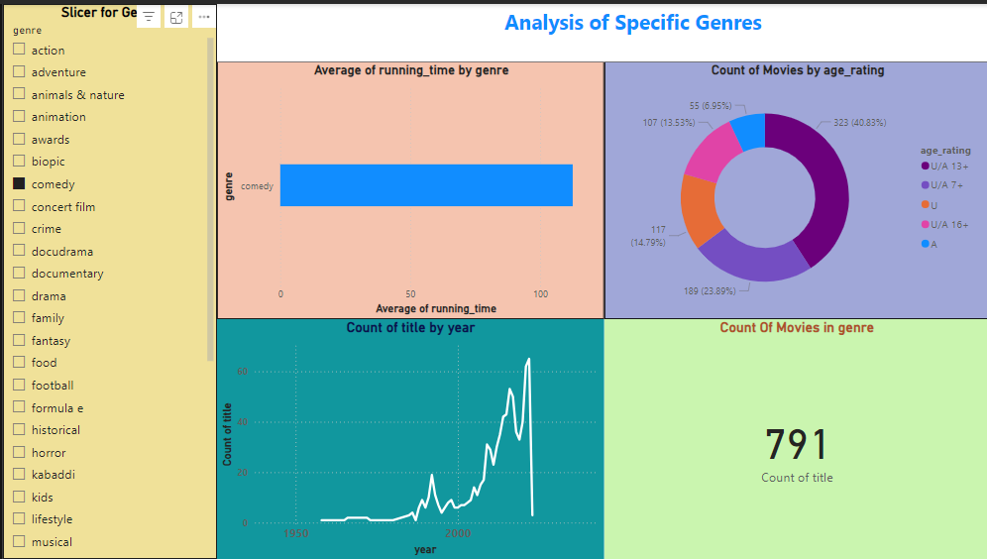

Overall Dashboard:

